**Contributor name:** Hemang Mittal

**Book Proposed:** Fundamentals_of_Applied_Statistics

**Total Chapters:** 9

**Total Examples:** 152

**Codable Examples:** 99

**Chapter 1: Statistical Quality Control**

Example 1.1 – Codable

Example 1.2 – Codable

Example 1.3 – Codable

Example 1.4 – Codable

Example 1.5 – Codable

Example 1.6 – Codable

Example 1.7 – Non-Codable (Reason: Theoretical example with the purpose of proving a concept)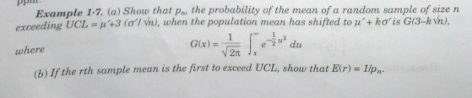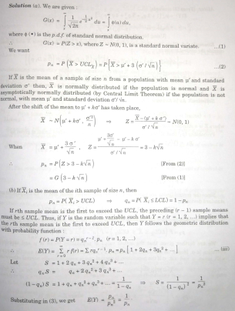

Example 1.8 – Non-Codable (Reason: Theoretical example with the purpose of proving a concept)

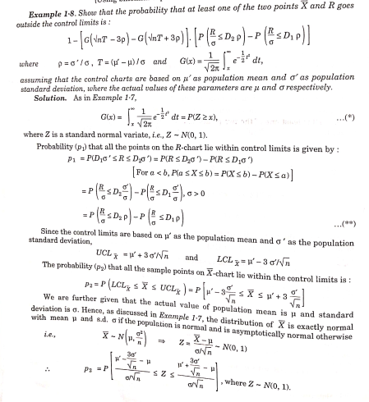

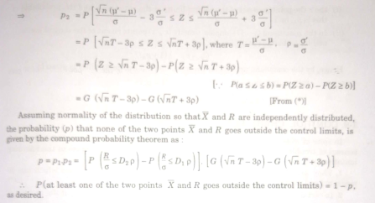

Example 1.9 – Non-Codable (Reason: Theoretical example with the purpose of proving a concept)

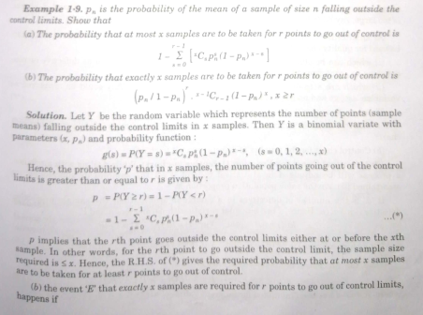

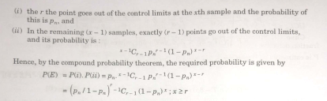

Example 1.10 – Codable

Example 1.11 – Codable

Example 1.12 – Codable

Example 1.13 – Codable

Example 1.14 – Codable

Example 1.15 – Codable

Example 1.16 –Codable

Example 1.17 –Codable

Example 1.18 –Codable

**Chapter 2: Analysis of Time Series**

Example 2.1 – Codable

Example 2.2 – Codable

Example 2.3 – Codable

Example 2.4 – Codable

Example 2.5 – Codable

Example 2.6 – Codable

Example 2.7 – Codable

Example 2.8 – Codable

Example 2.9 – Codable

Example 2.10 – Codable

Example 2.11 – Codable

Example 2.12 – Codable

Example 2.13 – Codable

Example 2.14 – Codable

Example 2.15 – Codable

Example 2.16 – Codable

Example 2.17 – Codable

Example 2.18 – Codable

Example 2.19 – Codable

Example 2.20 – Codable

Example 2.21 – Codable

Example 2.22 – Codable

Example 2.23 – Non-Codable (Reason: Theoretical example with the purpose of proving a concept)

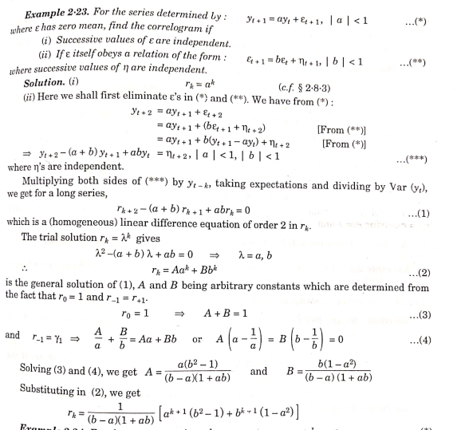

Example 2.24 – Non-Codable (Reason: Theoretical example with the purpose of proving a concept)

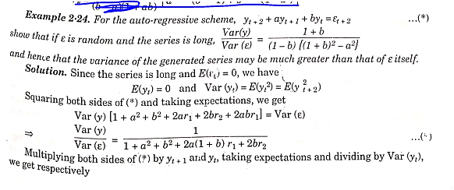

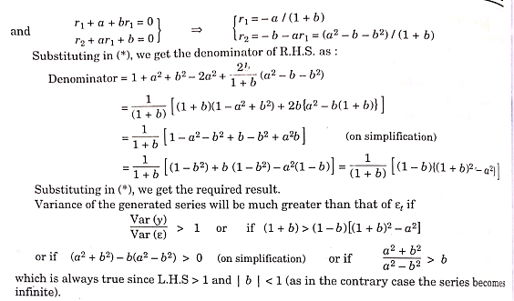

Example 2.25 – Non-Codable (Reason: Theoretical example with the purpose of proving a concept)

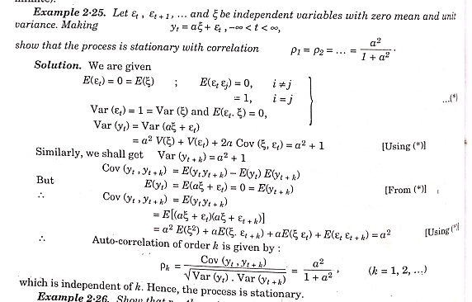

Example 2.26 – Non-Codable (Reason: Theoretical example with the purpose of proving a concept)

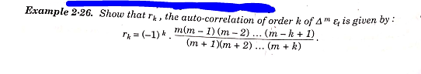

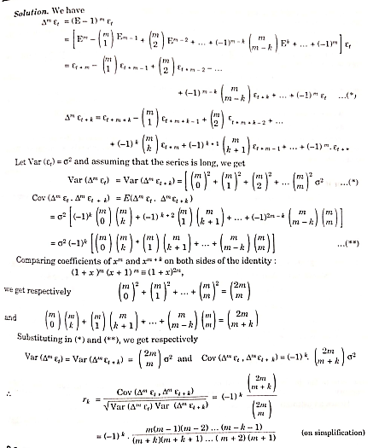

Example 2.27 – Codable

**Chapter 3: Index Numbers**

Example 3.1 – Codable

Example 3.2 – Codable

Example 3.3 – Codable

Example 3.4 – Non-Codable (Reason: Example involved variable expression)

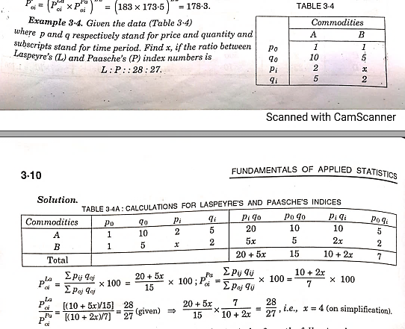

Example 3.5 – Codable

Example 3.6 – Codable

Example 3.7 – Non-Codable (Reason: Theoretical example with the purpose of proving a concept)

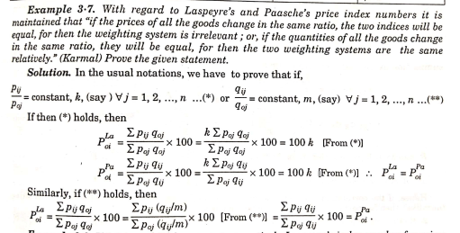

Example 3.8 – Non-Codable (Reason: Theoretical example with the purpose of proving a concept)

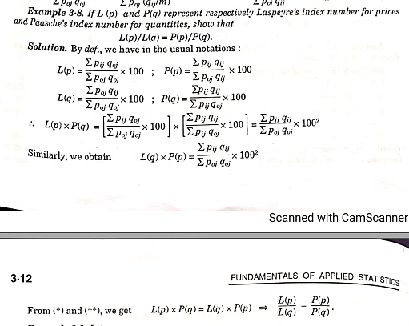

Example 3.9 – Non-Codable (Reason: Theoretical example with the purpose of proving a concept)

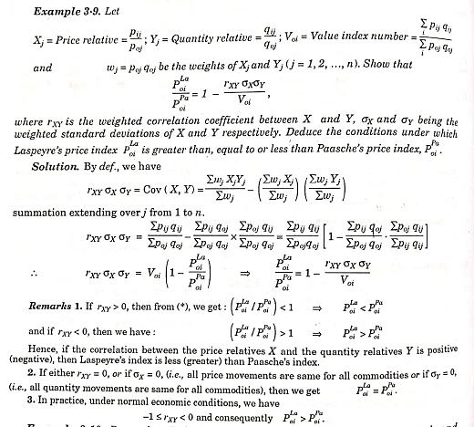

Example 3.10 – Non-Codable (Reason: Theoretical example with the purpose of proving a concept)

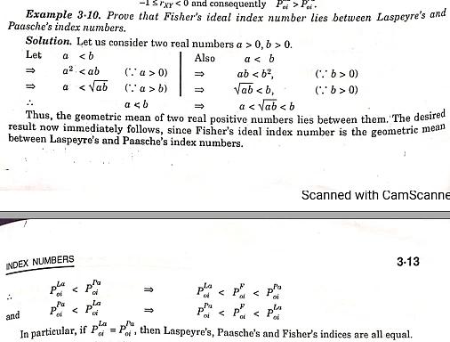

Example 3.11 – Non-Codable (Reason: Theoretical example with the purpose of proving a concept)

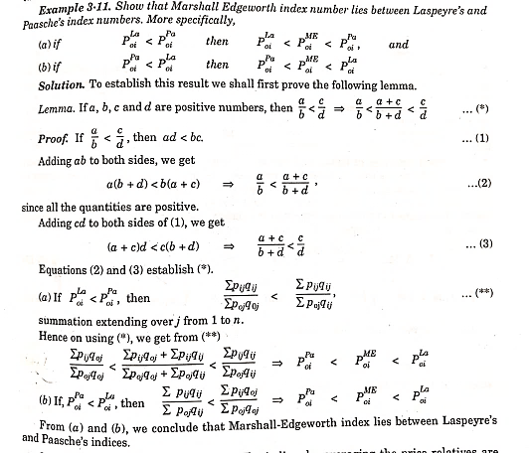

Example 3.12 – Codable

Example 3.13 – Codable

Example 3.14 – Codable

Example 3.15 – Codable

Example 3.16 – Codable

Example 3.17 – Codable

Example 3.18 – Codable

Example 3.19– Codable

Example 3.20 – Codable

Example 3.21 – Codable

Example 3.22 – Non-Codable (Reason: Example involved variable expression)

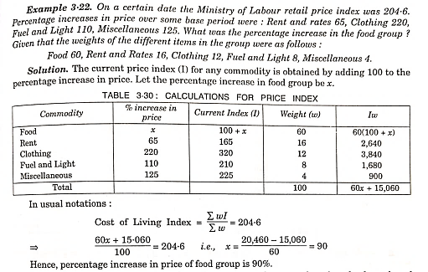

Example 3.23 – Codable

Example 3.24 – Codable

Example 3.25 – Codable

Example 3.26 – Non-Codable (Reason: Example involved variable expression)

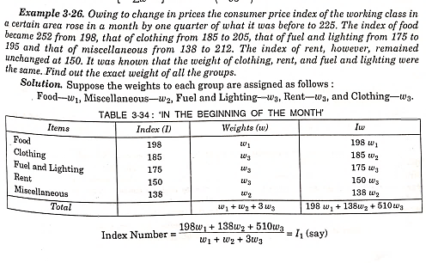

Example 3.27 – Codable

Example 3.28 – Codable

Example 3.29 – Codable

Example 3.30 – Codable

Example 3.31 – Codable

Example 3.32 – Codable

Example 3.33 – Non-Codable (Reason: Example involved variable expression)

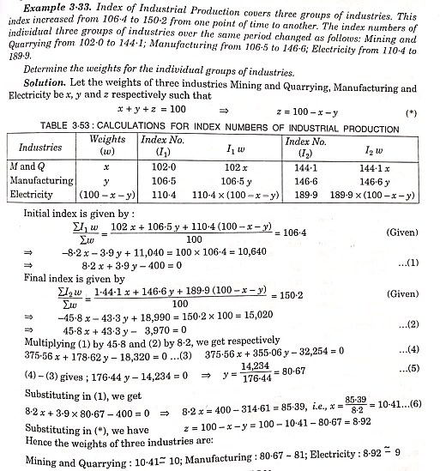

Example 3.34 – Codable

**Chapter 4: Demand Analysis**

Example 4.1 – Non-Codable (Reason: Example involved variable expression)

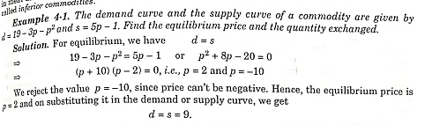

Example 4.2 – Non-Codable (Reason: Example involved variable expression)

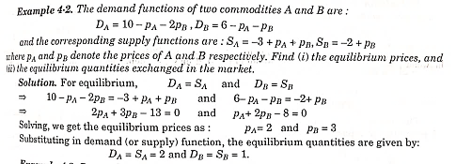

Example 4.3 – Non-Codable (Reason: Example involved variable expression)

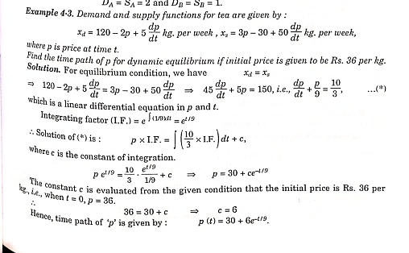

Example 4.4 – Non-Codable (Reason: Example involved variable expression)

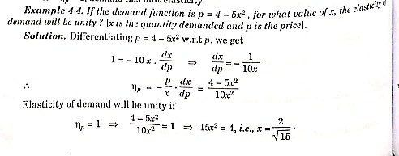

Example 4.5 – Non-Codable (Reason: Theoretical example with the purpose of proving a concept)

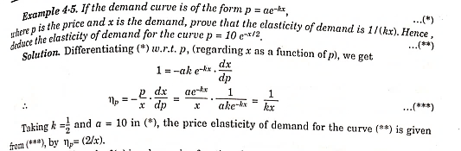

Example 4.6 – Non-Codable (Reason: Theoretical example with the purpose of proving a concept)

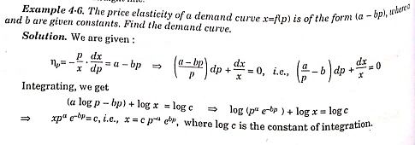

Example 4.7 – Non-Codable (Reason: Example involved variable expression)

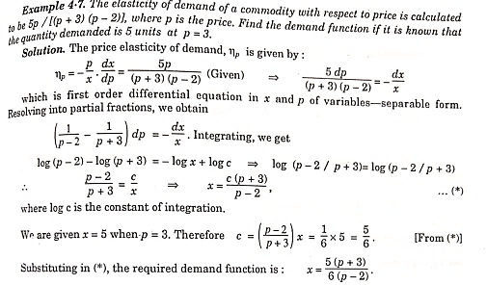

Example 4.8 – Non-Codable (Reason: Example involved variable expression)

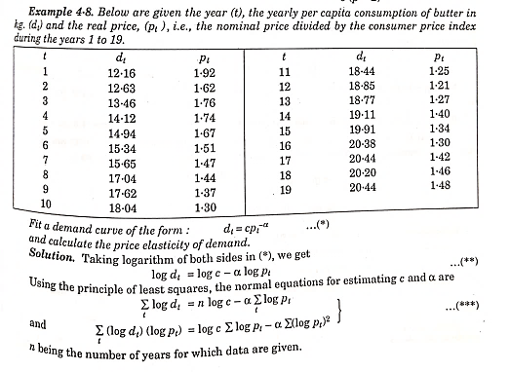

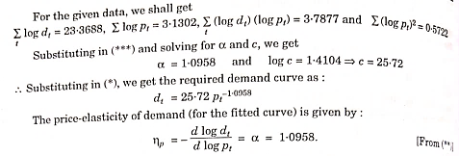

Example 4.9 – Non-Codable (Reason: Theoretical example with the purpose of proving a concept)

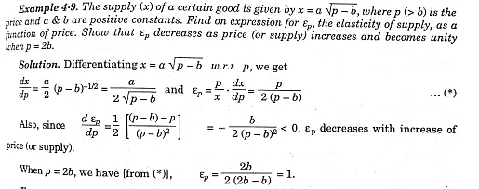

Example 4.10 – Non-Codable (Reason: Theoretical example with the purpose of proving a concept)

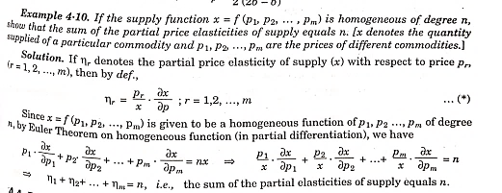

Example 4.11 – Codable

Example 4.12 – Non-Codable (Reason: Theoretical example with the purpose of proving a concept)

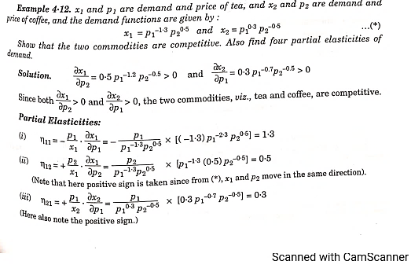

Example 4.13 – Non-Codable (Reason: Theoretical example with the purpose of proving a concept)

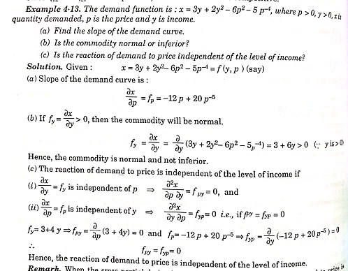

Example 4.14 – Codable

Example 4.15 – Non-Codable (Reason: Theoretical example with the purpose of proving a concept)

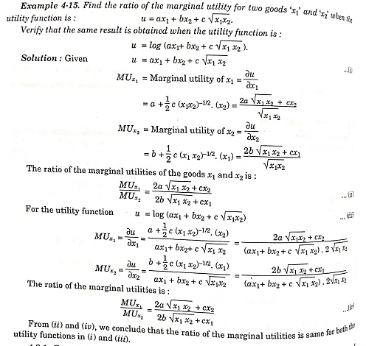

Example 4.16 – Non-Codable (Reason: Example involved variable expression)

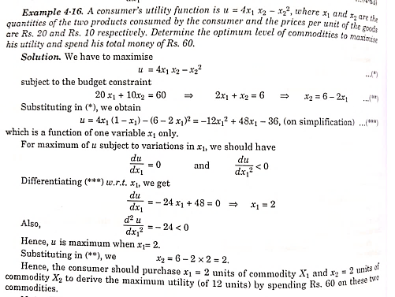

Example 4.17 – Non-Codable (Reason: Example involved variable expression)

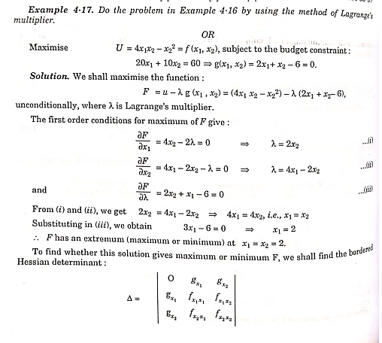

Example 4.18 – Non-Codable (Reason: Theoretical example with the purpose of proving a concept)

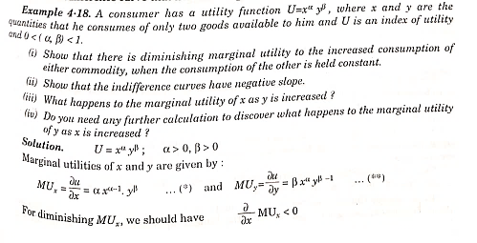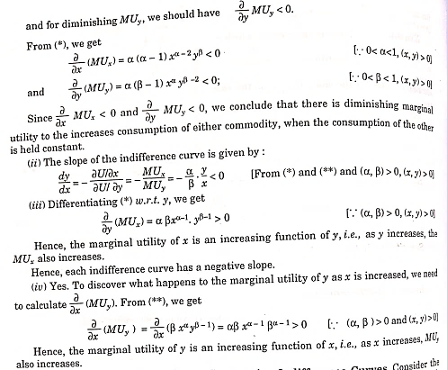

Example 4.19 – Non-Codable (Reason: Theoretical example with the purpose of proving a concept)

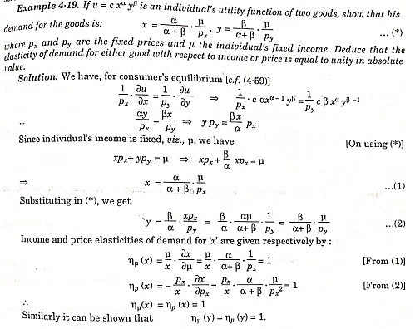

**Chapter 5: Analysis of Variance**

Example 5.1 – Codable

Example 5.2 – Codable

Example 5.3 – Codable

Example 5.4 – Codable

Example 5.5 – Codable

Example 5.6 – Codable

**Chapter 6: Design of Experiment**

Example 6.1 – Non-Codable (Reason: Theoretical example and answer based on the observation)

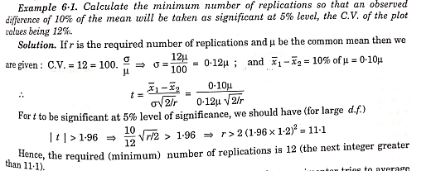

Example 6.2 – Codable

Example 6.3 – Codable

Example 6.4 – Codable

Example 6.5 – Non-Codable (Reason: Theoretical example with the purpose of proving a concept)

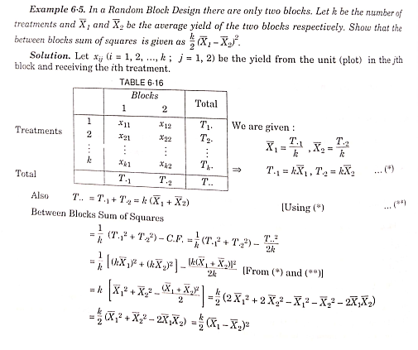

Example 6.6 – Codable

Example 6.7 – Codable

Example 6.8 – Non-Codable (Reason: Complex example, unable to code properly.)

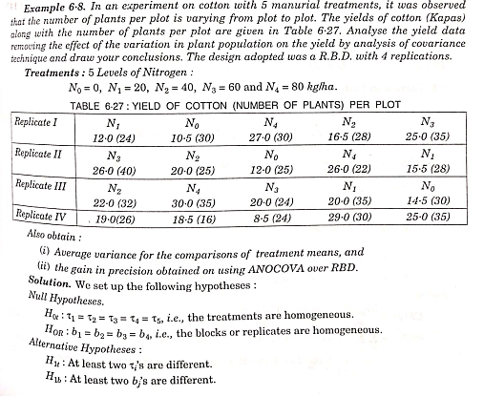

Example 6.9 – Codable

Example 6.10 – Codable

Example 6.11 – Codable

Example 6.12 – Codable

Example 6.13 – Non-Codable (Reason: Theoretical example with the purpose of proving a concept)

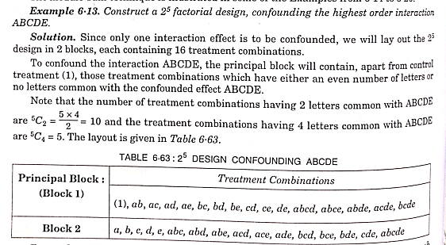

Example 6.14 – Non-Codable (Reason: Theoretical example with the purpose of proving a concept)

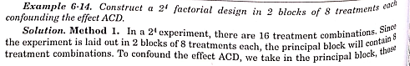

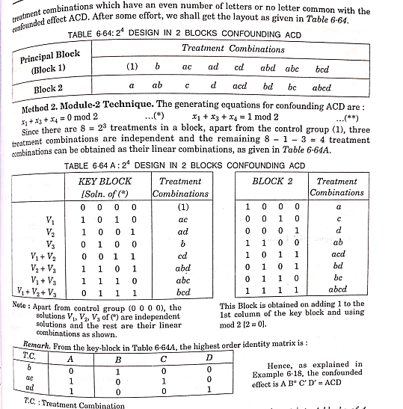

Example 6.15 – Non-Codable (Reason: Theoretical example with the purpose of proving a concept)

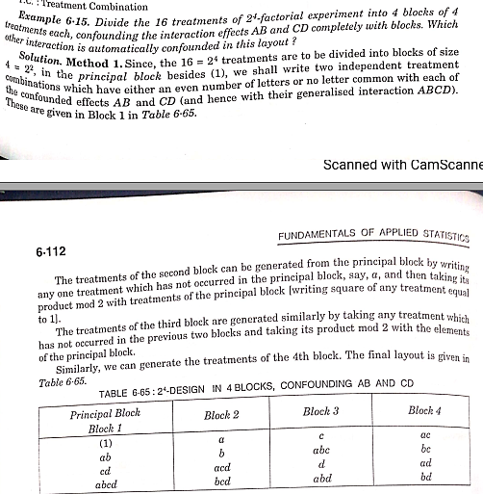

Example 6.16 – Non-Codable (Reason: Theoretical example with the purpose of proving a concept) 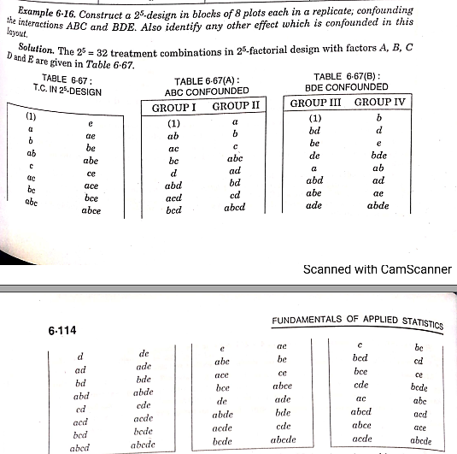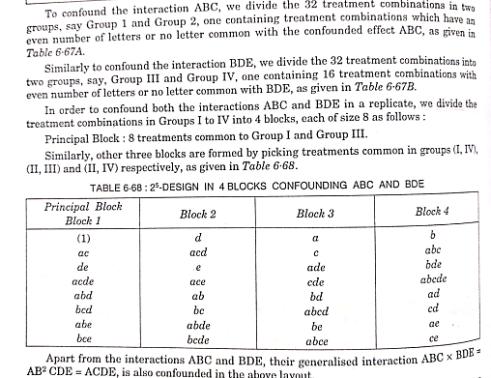

Example 6.17 – Non-Codable (Reason: Theoretical example with the purpose of proving a concept) 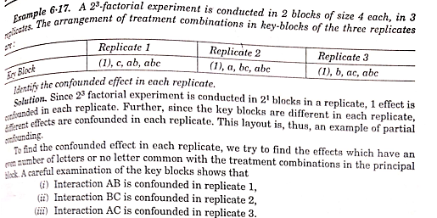

Example 6.18 – Non-Codable (Reason: Theoretical example with the purpose of proving a concept) 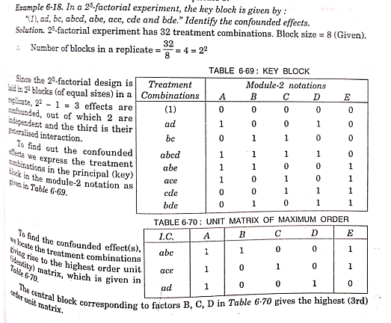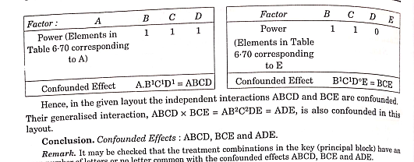

Example 6.19 – Non-Codable (Reason: Theoretical example with the purpose of proving a concept) 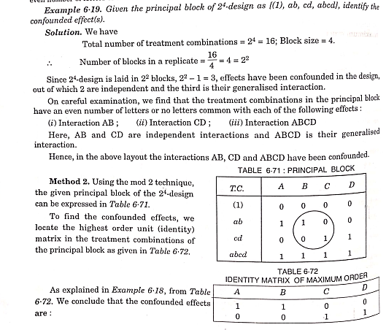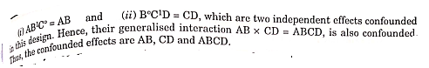

Example 6.20 – Non-Codable (Reason: Theoretical example with the purpose of proving a concept)

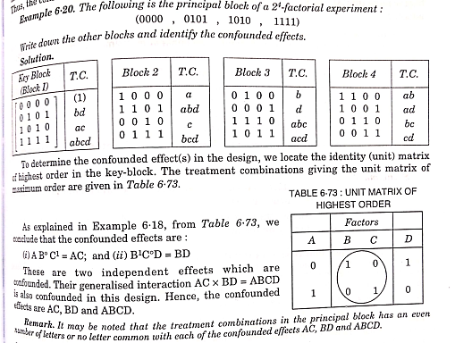

Example 6.21 – Codable

**Chapter 7: Design of Sample Surveys**

Example 7.1 – Non-Codable (Reason: Theoretical example to draw random sample based on table of random numbers)

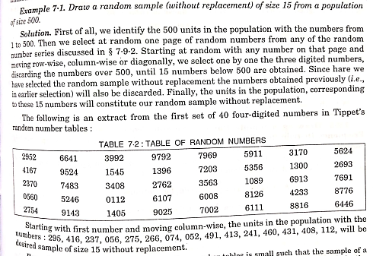

Example 7.2 – Non-Codable (Reason: Theoretical example to draw random sample based on table of random numbers)

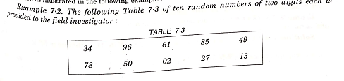

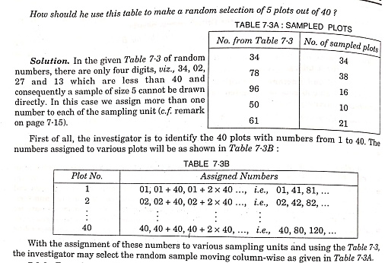

Example 7.3 – Non-Codable (Reason: Theoretical example to draw random sample)

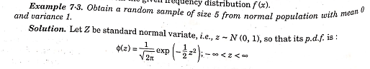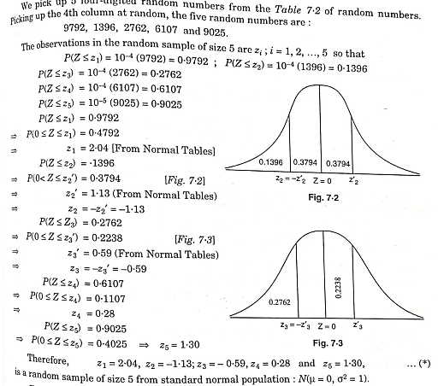

Example 7.4 – Non-Codable (Reason: Theoretical example to draw random sample)

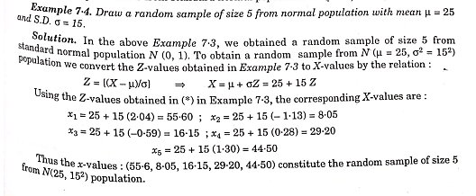

Example 7.5 – Non-Codable (Reason: Theoretical example with the purpose of proving a concept)

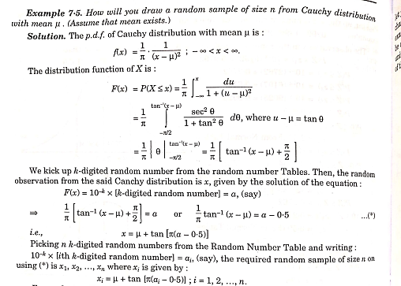

Example 7.6 – Non-Codable (Reason: Theoretical example with the purpose of proving a concept) 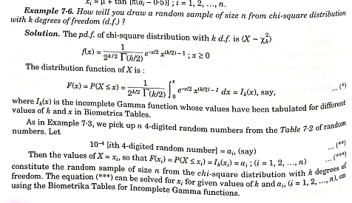

Example 7.7 – Codable

Example 7.8 – Non-Codable (Reason: Theoretical example with the purpose of proving a concept) 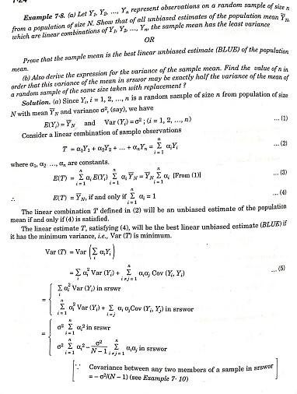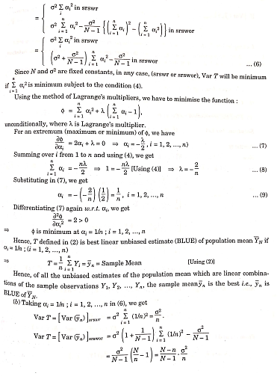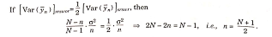

Example 7.9 – Non-Codable (Reason: Theoretical example with the purpose of proving a concept) 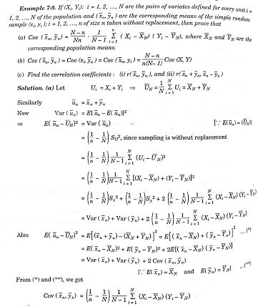

Example 7.10 – Non-Codable (Reason: Theoretical example with the purpose of proving a concept) 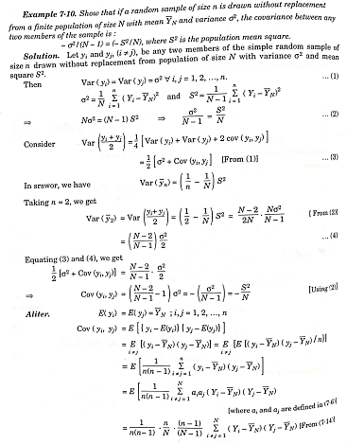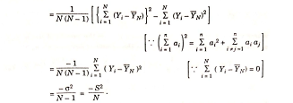

Example 7.11 – Non-Codable (Reason: Theoretical example with the purpose of proving a concept) 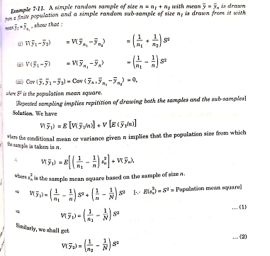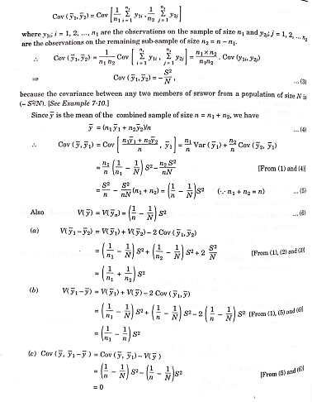

Example 7.12 – Non-Codable (Reason: Theoretical example with the purpose of proving a concept) 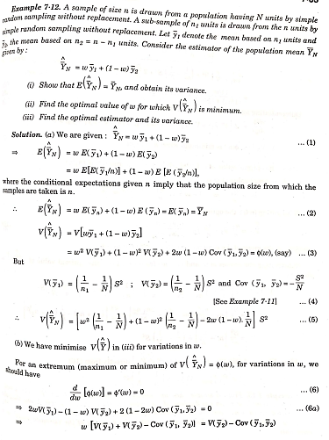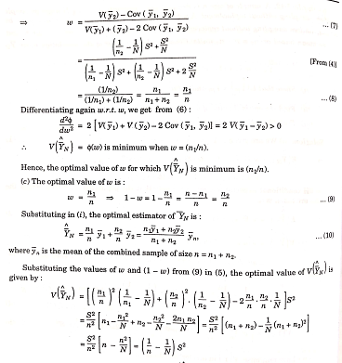

Example 7.13 – Non-Codable (Reason: Theoretical example with the purpose of proving a concept) 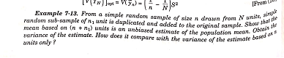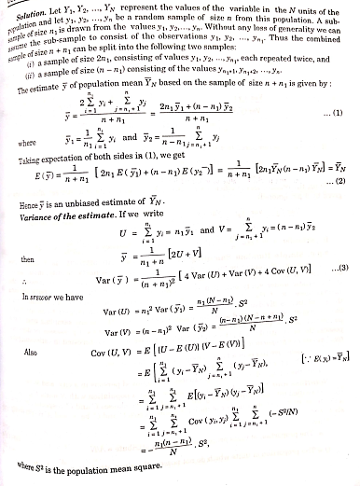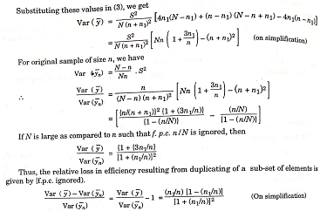

Example 7.14 – Codable

Example 7.15 – Codable

Example 7.16 – Non-Codable (Reason: Theoretical example with the purpose of proving a concept) 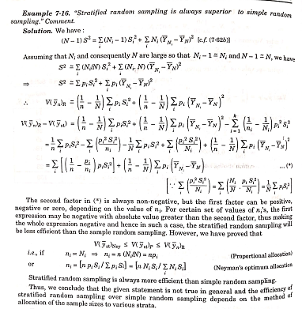

Example 7.17 – Non-Codable (Reason: Theoretical example with the purpose of proving a concept) 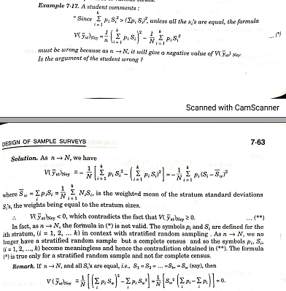

Example 7.18 – Non-Codable (Reason: Theoretical example with the purpose of proving a concept) 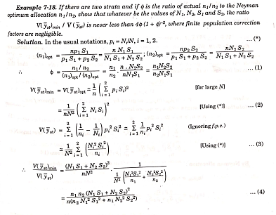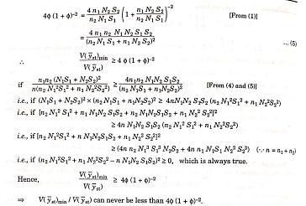

Example 7.19 – Non-Codable (Reason: Theoretical example with the purpose of proving a concept) 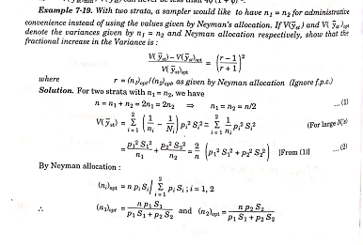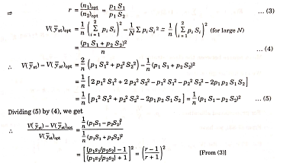

Example 7.20 – Non-Codable (Reason: Theoretical example with the purpose of proving a concept) 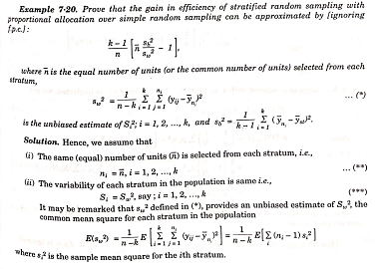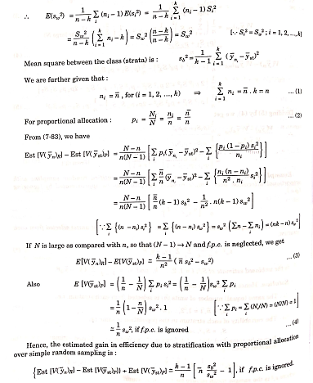

Example 7.21 – Codable

Example 7.22 – Non-Codable (Reason: Theoretical example with the purpose of proving a concept) 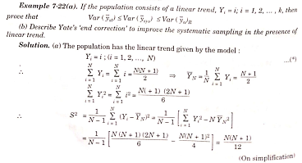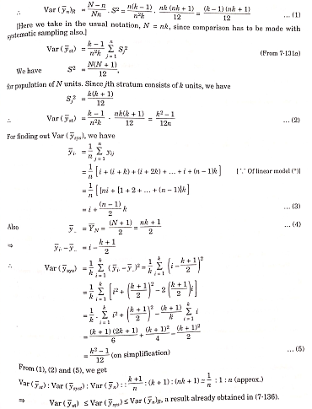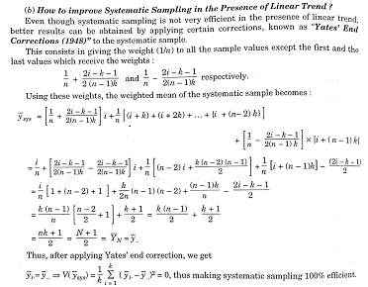

**Chapter 8: Statistics in Psychology and Education**

Example 8.1 – Codable

Example 8.2 – Codable

Example 8.3 – Codable

Example 8.4 – Codable

Example 8.5 – Codable

Example 8.6 – Codable

Example 8.7 – Codable

Example 8.8 – Codable

Example 8.9 – Codable

Example 8.10 – Codable

Example 8.11 – Codable

Example 8.12 – Non-Codable (Reason: Theoretical example with the purpose of proving a concept)

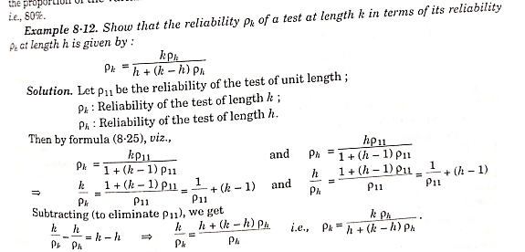

**Chapter 9: Vital Statistics**

Example 9.1 – Codable

Example 9.2 – Codable

Example 9.3 – Codable

Example 9.4 – Non-Codable (Reason: Theoretical example with the purpose of proving a concept) 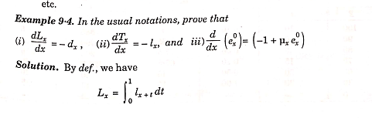 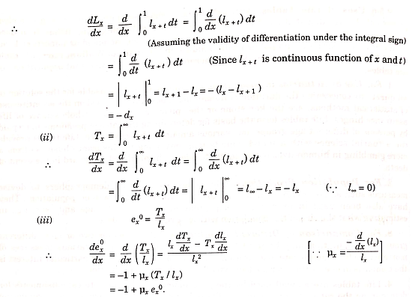

Example 9.5 – Codable

Example 9.6 – Codable

Example 9.7 – Codable

Example 9.8 – Codable

Example 9.9 – Codable

Example 9.10 – Codable

Example 9.11 – Codable

Example 9.12 – Codable

Example 9.13 – Codable

Example 9.14 – Codable